**Jenkins Integration With Selenium – Method**

### How To Install Maven?

**Step 1:** Download Maven from their official [website](https://maven.apache.org/download.cgi).

**Step 2:** Add MAVEN_HOME system variable.

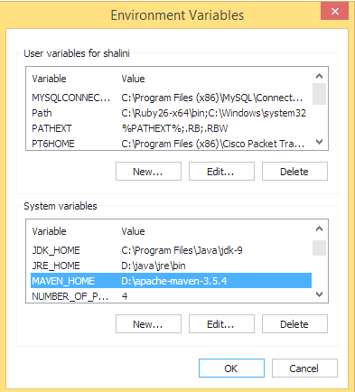

**Step 4:** To verify the successful installation of Maven, type mvn –version in the command prompt.

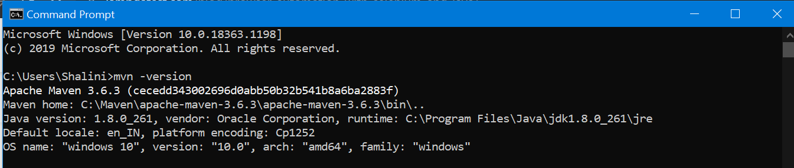

**step 3:** Set the path which points to the bin directory of the maven directory.

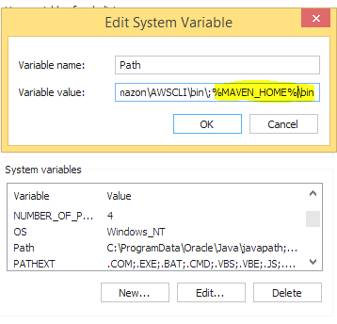

**Step 4:** To verify the successful installation of Maven, type mvn –version in the command prompt.



**Step 5:** Create a maven project and add all the maven dependencies in the pom.xml file.

project

2

xmlns="http://maven.apache.org/POM/4.0.0"

3

4

xmlns:xsi="http://www.w3.org/2001/XMLSchema-instance" xsi:schemaLocation="http://maven.apache.org/POM/4.0.0 http://maven.apache.org/xsd/maven-4.0.0.xsd">

5

6

 <modelVersion>4.0.0</modelVersion>

7

8

 <groupId>demoProject</groupId>

9

10

 <artifactId>demoProject</artifactId>

11

 <version>0.0.1-SNAPSHOT</version>

12

 <build>

13

<sourceDirectory>src</sourceDirectory>

14

<plugins>

15

<plugin>

16

  <artifactId>maven-compiler-plugin</artifactId>

17

  <version>3.8.0</version>

18

19

  <configuration>

20

21

    <source>1.8</source>

22

23

    <target>1.8</target>

24

25

  </configuration>

26

27

</plugin>

28

29

</plugins>

30

31

 </build>

32

 <dependencies>

33

34

          <dependency>

35

36

         <groupId>org.seleniumhq.selenium</groupId>

37

38

         <artifactId>selenium-java</artifactId>

39

40

         <version>3.141.59</version>

41

42

          </dependency>

43

<dependency>

44

45

   <groupId>org.testng</groupId>

46

   <artifactId>testng</artifactId>

47

   <version>7.3.0</version>

48

   <scope>test</scope>

49

</dependency>

50

 </dependencies>

51

</project>

**Step 1:** Start the Jenkins server.

**Step 2:** Open the browser and navigate to the localhost and the port in which Jenkins is running.

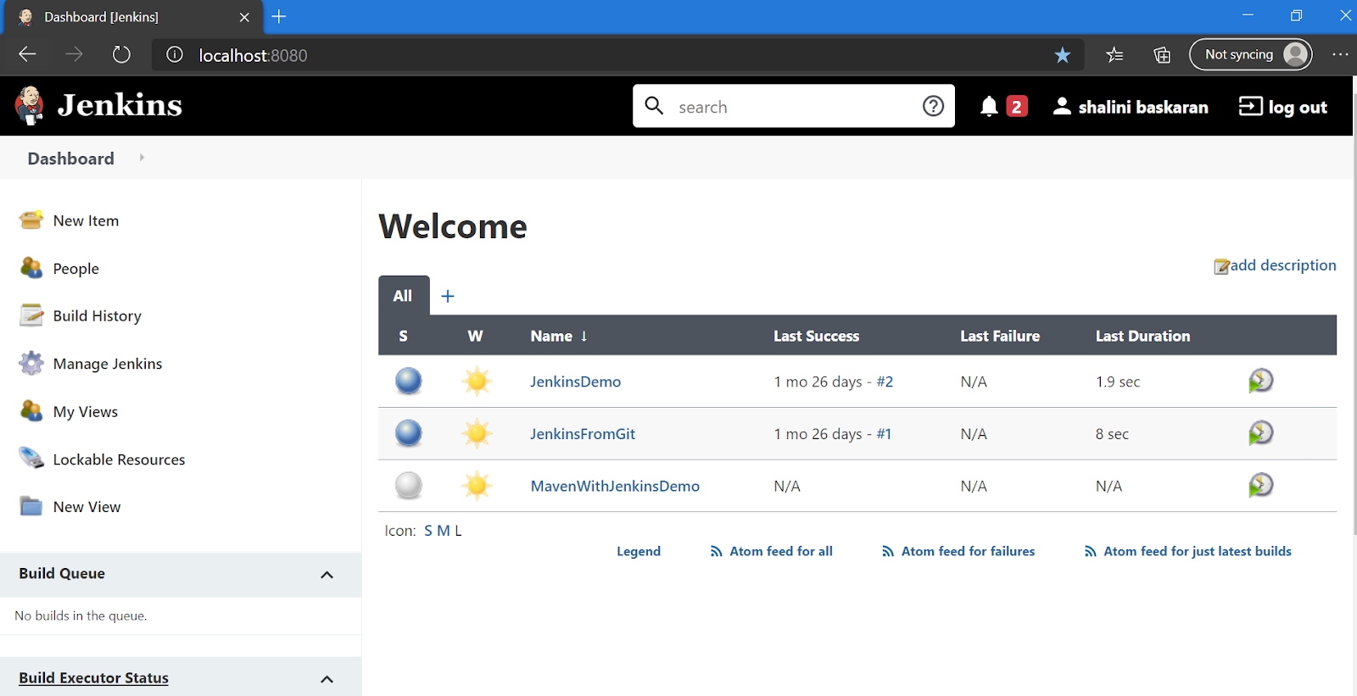

**Step 3:** Click **New Item** in the dashboard.

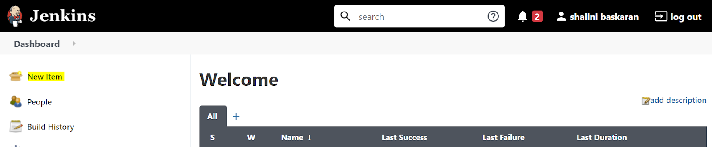

**Step 4:** Enter the project name and select the project type as **Maven project**.

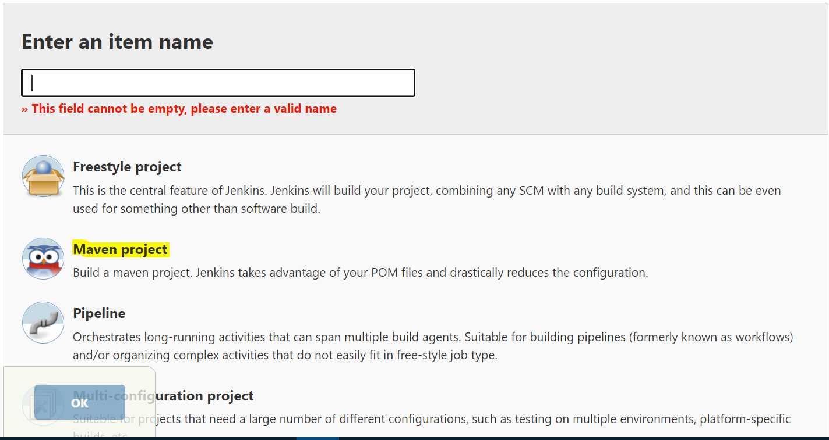

**Step 5:** Click **Ok**. Now you could see a job being created successfully in the dashboard.

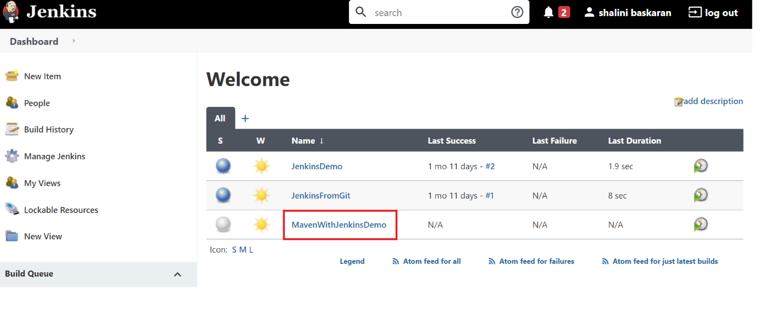

**Step 6:** Click the project and click **Configure**.

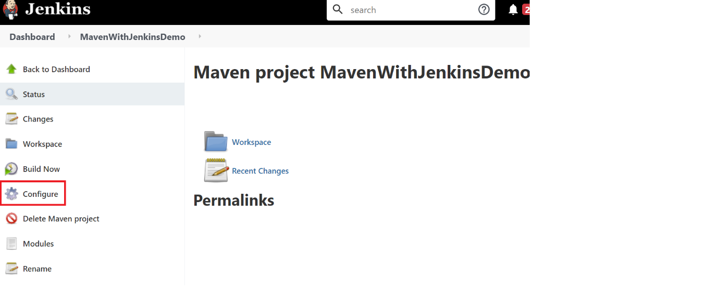

**Step 7:** Under the Build section, enter the complete path of your pom.xml . In the Goals and options, enter the command clean test.

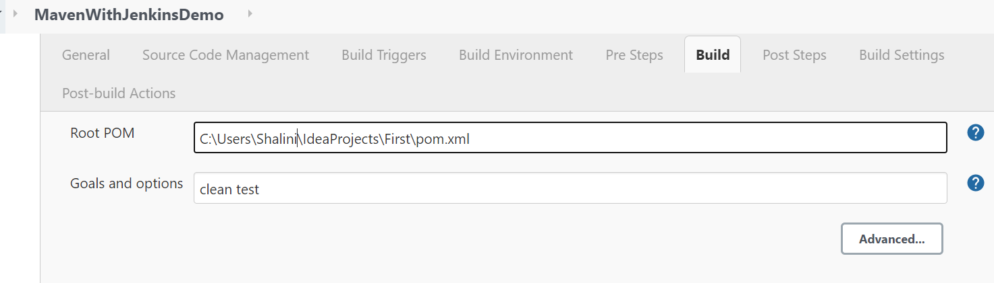

**Step 8:** Click **Apply** and then **Save**.

**Step 9:** Click **Build Now**.

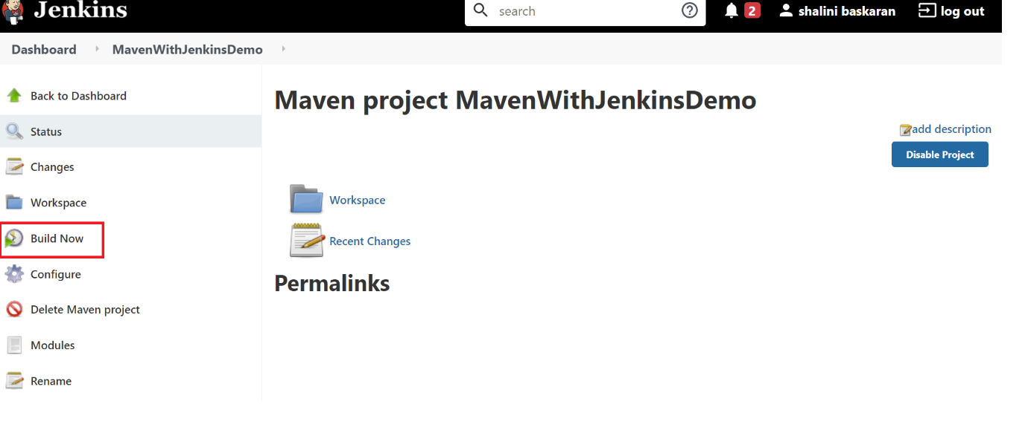

**Step 10:** Now the build will run and, after successful completion of the build, the results would be displayed. To view the complete logs, click the console output.

